3.4 Performance Assessment Part 2: Angular Integration

Christopher Crayton
ECPI University
SDC360: Web Application Development
Mohammad Zakaria
March 22, 2026

3.4 Performance Assessment Part 2: Angular Integration
Initial Run:
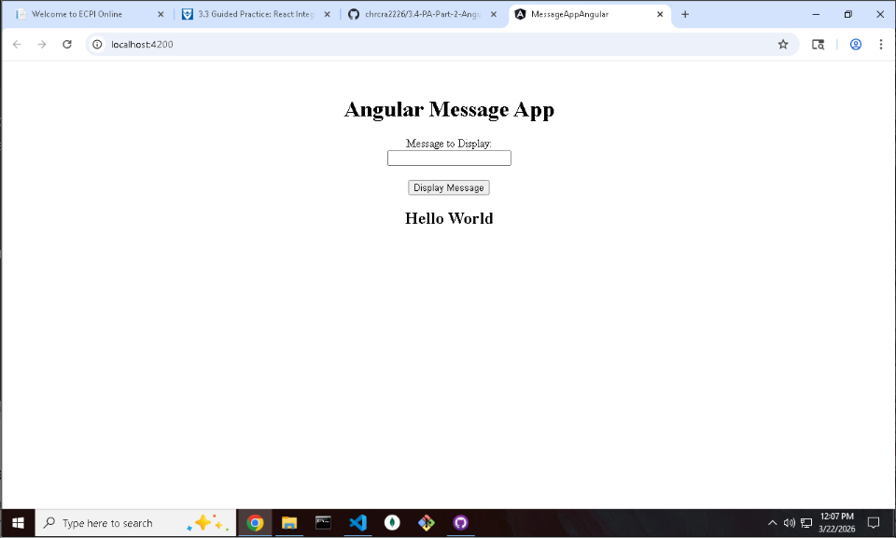
Entered Text:
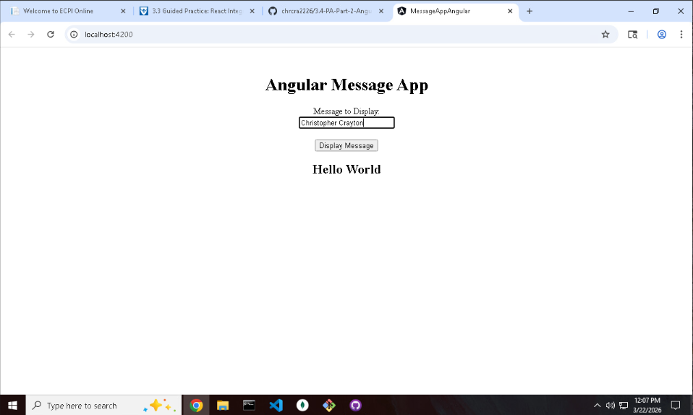
Message Delivered:
